# INTRODUCTION

Currency is something that is released by the government to utilize services. Among all other alternative forms of currency, the most preferable form of the currency is the paper. As part of the technological progression introduced to the banking sectors, financial institutions and banking had started financial self-services. By using an ATM counter and a Coin dispenser automated banking system is achieved where machines are used to handle currencies. In such systems, the machine uses methods to recognize the correct currency.

Currency has two types of features internal and external features. External features include the physical aspects of the currency like width and size. But these physical features are not reliable because currencies may damage due to circulation. Due to this damaged currencies system may fail to recognize currencies. The internal feature includes the Color feature, which is also not reliable because currencies are passed through various hand and due to this, it becomes wrinkled. For currencies of each denomination, there is a specific color and size followed by RBI (Reserve Bank of India).

It is very simple for a human to identify the denomination of currency notes because our brain is extremely skillful in learning new things and discovering them later without much trouble. But this currency recognition task turns very challenging through machines (Computers), in cases when currencies become damaged, old, and faded due to wear and tear.

Security features are included in every Indian Currency which provides help in recognition and identification of the currency value. Various Security features are identification mark (shape), Center value, Ashoka, Latent image, See-through register, Security thread, Micro letter, Watermark, and RBI seal.

Basically, the images are read from different derivations. However, we delimit our system which can read the currency from the scanner. The device that the system needs is very common in our daily life, so we do not need to buy an extra device to realize the system. There are a number of challenges while creating such a robust system, Including:

1. Most of the techniques are sensitive to illumination and many of them rely on taking images in fixed environment settings such as camera location and image background.
2. There is a requirement of the large dataset for training samples used to avoid overfitting and poor generalization.
3. Also, if the distribution of training samples is not uniform, then the result will not come as needed.
4. Removal of noise during image processing is very necessary.The recognition rate decreases due to them, which cannot be neglected.
5. During image processing, noise removal requires the processes of smoothing and local averaging which In turn blurs the edges of the images which is a necessary part of our recognition process.
6. The bigger is the dataset, the more complex is the neural network and hence we require powerful hardware and a stronger GPU system to reduce the time taken.
7. The images that are taken are in the form of pixels. Bigger dataset means millions of pixels are to be matched which we require an efficient and optimal algorithm to reduce the time is taken.

In our project, we have tried to solve most of these problems and get an optimum method to recognize currency.

1. **SYSTEM REQUIREMENTS**
   1. **Hardware requirements:**

The hardware requirements are based on the computational power required for training the deep learning model on a large dataset of currency images. The graphics card is required for training the model using the CUDA framework.

* Processor: Intel Core i5 or higher
* RAM: 8 GB or higher
* Storage: 100 GB or higher
* Graphics card: NVIDIA GTX 1050 or higher
  1. **Software requirements**

The software requirements include the necessary packages and libraries required for developing the back-end of the system, including Python, TensorFlow, Keras, OpenCV, and Flask. Additionally, HTML, CSS, and JavaScript will be used for developing the user interface for the currency identification system.

* Operating System: Windows 10 or Ubuntu 18.04
* Python 3.6 or higher
* Tensorflow 2.0 or higher
* Keras
* OpenCV
* Flask
* HTML, CSS, and JavaScript for front-end development

# PRELIMINARY INFORMATION

* 1. **Edge Detection Technique**:

Edge detection is a type of image segmentation technique where edges are detected in the image. Edges are introduced as a set of connected points lie on the boundary between the two regions. The edges represent object boundaries and therefore can be used in image segmentation to subdivide an image into its basic regions or objects.

**3.1.1 Sobel Edge Detection:**

The Sobel operator measures a 2-Dimensional spatial gradient on an image and gives more attention to regions of high spatial gradient corresponding to edges. It is used for finding gradient magnitude at each point in a grayscale image. The​ Sobel operator is based on convolving the image with a small, separable, and integer-valued filter in the horizontal and vertical directions and is therefore relatively inexpensive in terms of computations.

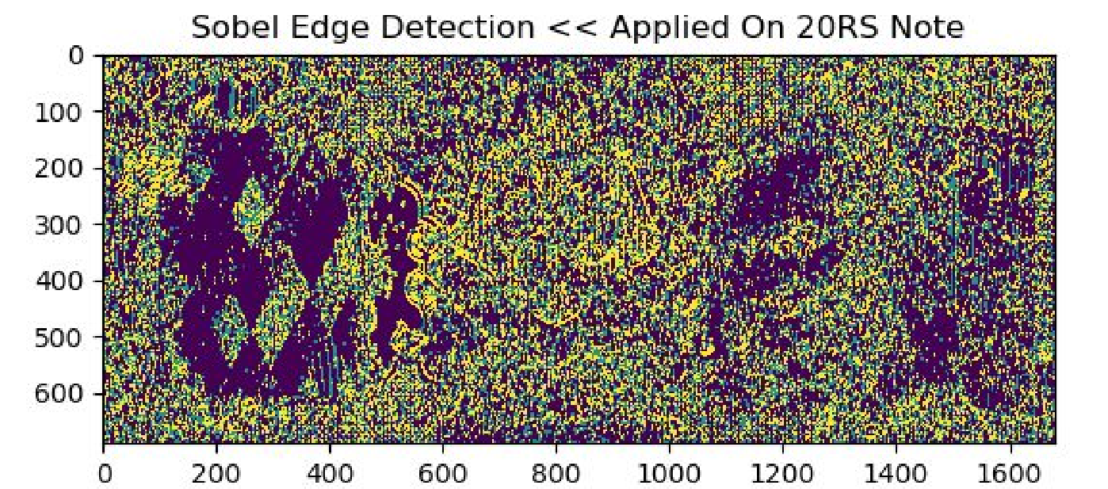

**3.1.2 Canny Edge Detection:**

The Canny edge detection algorithm was proposed to enhance the edge detection process. Three important criteria were taken into consideration for this purpose. The first and most important criterion was to detect all the important edges in the source image. This means the goal was to lower the error rate. The second criterion was that the edge points to be detected as close as possible to the true edge also called localization. A third criterion was not to have more than one response to a single edge. The first two were not significant enough to remove the possibility of more than one response to an edge due to which the third one was implemented.

The Canny edge detector was thus implemented on these criteria. It first smooths the image to eliminate noise. Then the image gradients are calculated to point out those regions where the gradient difference is maximum, which have high spatial differences. Finally, it then tracks along these regions and discards any pixel that weakly defines an edge (non-maxima suppression) in order to make the edges thinner.

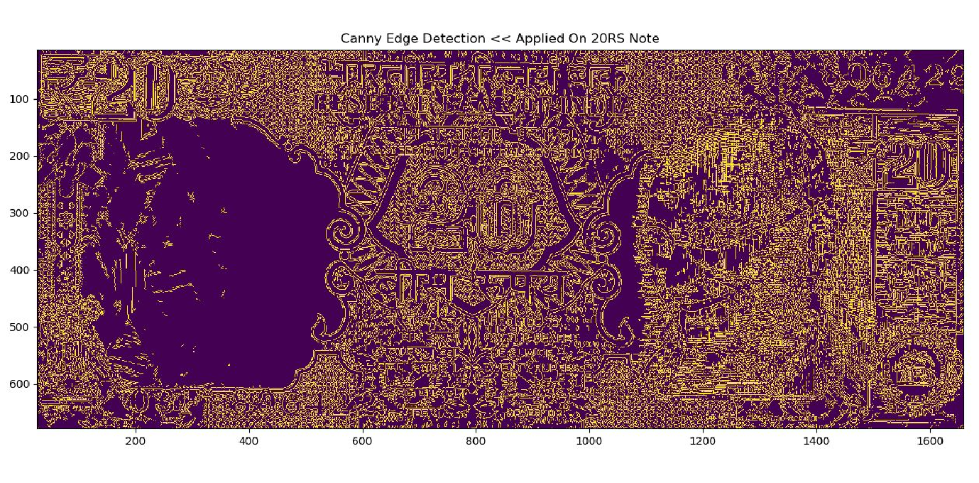

* 1. **Convolutional Neural Network**

The convolutional neural network (CNN) is a class of neural networks of deep learning. CNN is a major innovation in image recognition. They are most often used to analyze visual images and often work behind the scenes on the classification of images. We find them at the heart of everything from tagging Facebook photos to autonomous cars.

The convolutions are defined by two parameters:

1. Size of the extracted blocks (usually 3x3 or 5x5 pixels).

2.The depth of the output resource map, which is the number of filters applied. During the training, CNN "learns" the optimal values of the filter matrices to extract important resources (textures, borders, shapes) from the input resource map. As the number of filters (output resource mapping depth) applied to the input increases, the number of resources that can be retrieved by CNN also increases. 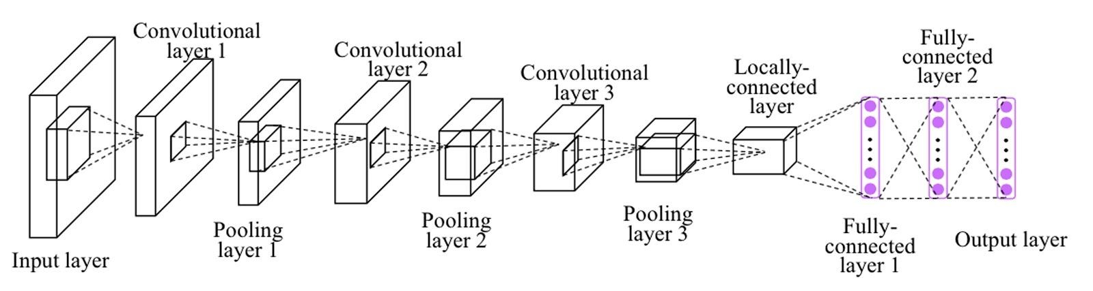

# PROBLEM STATEMENT

To create an application for efficient and correct recognition of Bank Notes.

This project would be helpful in numerous fields to be its banking system or helping the blinds to detect which Bank Note is presented to him/her.

However, currency recognition systems that are based on image analysis entirely are not sufficient. Most of the present systems only recognize Banknotes which are not wrinkled. Due to this, they are not very effective to be used in real life.

Our system is based on image processing and makes the process automatic and robust.

# OBJECTIVES

The objective of this Intelligent Currency Recognition System is to analyze and detect a banknote fed to it as input and generate favorable output in an efficient manner by the use of Image Processing and Machine learning techniques.

1. To process and identify banknotes as inputted by the user in less time.
2. To propose a cost-effective solution to the problem of Currency recognition.
3. To efficient recognize banknotes with wear and tear with utmost accuracy.
4. To replace the outdated method of currency recognition with a more efficient and effective system.

# 6. LITERATURE SURVEY

A large number of researchers have made several contributions toward developing techniques for currency recognition. The different properties between coins and bills make researchers deal with the recognition task differently for each one of them.

It has been previously proposed an image processing technique to extract paper currency denomination. The extracted Region of Interest (ROI) is used with pattern recognition and neural network matching techniques. In this method, they captured the images by the simple flat scanner with a fixed size and then some filters are applied to extract the denomination value of the banknote.

**7. AUTHOR**

**7.1 Author: Iyad Abu And Doush Saha**

## **Currency recognition using a smartphone: Comparison between color SIFT and grayscale SIFT algorithms: Journal of King Saud University – Computer and Information Sciences** [**​Volume 29, Issue 4​**](https://www.sciencedirect.com/science/journal/13191578/29/4)**, Pages 484-492, October 2017**

Currency recognization in an uncontrolled environment (i.e., using a smartphone) is not an easy task because of the multiple variable conditions that could affect the quality of the image. The experimental results have shown the effectiveness of the SIFT algorithm in general for Jordanian banknote recognition, although our algorithm is tested in a more challenging dataset with the images taken in different conditions. The system depends on the appearance of the object at specific interest points. The results show that the recognition accuracy for coin currencies is less than recognition accuracy for paper currencies. This happened because of the illumination condition that affects the coin’s image.

## Critical ​ Reviews:​

The paper provided good results in the case of paper banknotes except for some cases such as:

1. Too wrinkled: it was difficult to match the exact descriptors (some key-points did not appear or changed).
2. Folded several times: it was difficult to match the exact descriptors (some key-points do not appear or changed).
3. Take image from a close distance: crop large portion of the image which means it was difficult to match the exact descriptors (a large number of key-points do not appear).
4. Take image from too far distance: crop large portion of the background which means it was difficult to match the exact descriptors (large numbers of redundant key-points appear).

The conclusion from the paper was that currency recognition in an uncontrolled environment is not an easy task because of the multiple variable conditions that could affect the quality of the image. The experimental results had shown the effectiveness of SIFT The algorithm in general for Jordanian banknote recognition, although the algorithm is tested in a more challenging dataset with the images taken in different conditions.

It was observed from the results that the number of detected features in the color SIFT is larger than that in the gray SIFT. The evaluation results show the high performance of color SIFT when compared with gray SIFT descriptors in terms of processing time and accuracy rate.

**7.2 Author: B. Sai Prasanthi, Rajesh Shetty**

### **Indian Paper Currency Authentication System using Image processing: International Journal of Scientific Research Engineering & Technology (IJSRET), ISSN 2278 – 0882 Volume 4, Issue 9, September 2015**

The features are extracted using edge-based segmentation by Sobel operator and work well in the whole process with less computation time. The complete methodology works for Indian denomination 20,50,100, 500 and 1000. The method is very simple and easy to implement. If the hardware part of image acquisition is designed then it surely helps us to minimize the problem of counterfeiting currency. This technique is used to extract six characteristics of paper currency including identification mark, security thread, floral design, numeral watermark, watermark, micro-lettering in security thread. The system may extract the hidden features i.e. the latent image of the paper currency. The proposed work is an effort to suggest an approach for the characteristic extraction of Indian paper currency. The detailed approach is suggested from the beginning of image acquisition to converting it to grayscale image and up to characteristic features extraction.

**Critical Reviews:**

The proposed work was an effort to suggest an approach for the characteristic extraction of Indian paper currency. The detailed approach is suggested from the beginning of image acquisition to converting it to grayscale image and up to characteristic features extraction. The decision making is done within 0.5 seconds. The system designed is a low-cost system. The system is able to extract the features even the note has scribblings on it. The system can extract features even the test image sizes are different when compared to the reference image.

**7.3 Author: S.K. Katiyar and P.V Arun**

### **Comparative analysis of common edge detection techniques in the context of object extraction, Department Of Civil Engineering MA National Institute of Technology, India IEEE TGRS Vol.50 no.11b**

The major disadvantage of the Sobel algorithm is that with the increase in noise the gradient magnitude of the edges also degrades which produces inaccurate results. Hence, was unable to detect the appropriate edges. The Canny edge detection, on the other hand, was accurate enough to produce the required results. The thresholding method provides good edge detection in Canny.

The difference between Canny and Sobel becomes clear through figure which shows the original image as well as the output image as produced by Canny and Sobel. The output of the Sobel operator is a blurred image with edges being overlapped. On the other hand, the Canny operator gives a clear difference in edges that come under the texture.

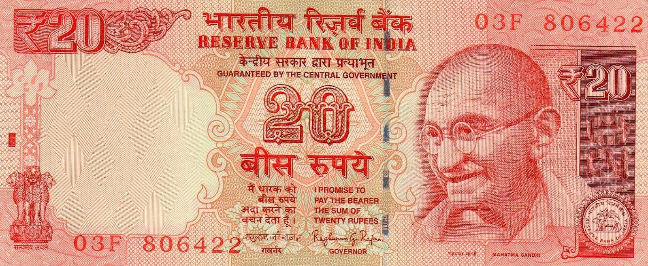

### (Original Image​ ​)

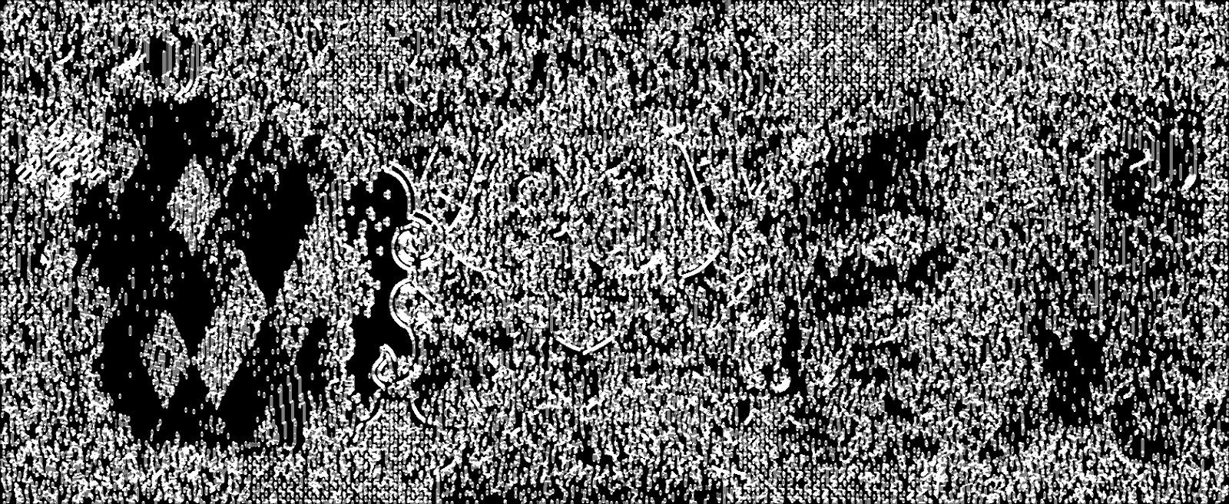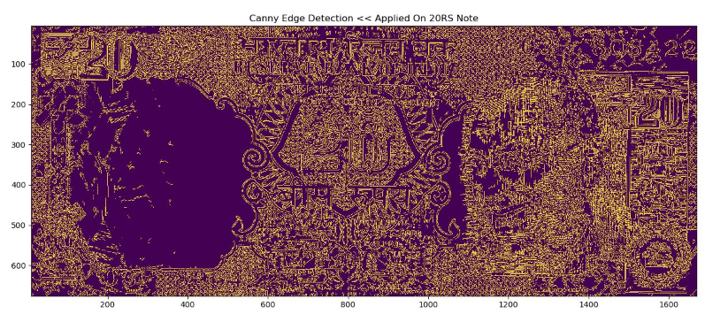

### (Sobel Edge Detection​ ​) (Canny Edge Detection​ ​)

**Critical reviews:**

The investigations of present research work have led to the following conclusions:

* The canny method outperforms all the other methods even though its computational complexity is higher. Canny can be used for the extraction of even objects with feeble edges.
* The Sobel also detects the various features and is computationally more efficient as Canny but with more false edges. Sobel is optimum for objects with Strong edges as lakes, Stadium, etc.
* The other algorithms as Robert and Prewitt also detect the various features and stadiums but fail in case of smaller features and the range of usable thresholds is very low.
* For any method of edge detection, the computational complexity increases with the increase in spatial resolution.

The issues faced during the experiments were that the ground truth verification confirmed that the edge detection is affected by shadows, salt and pepper noise which deflated the expected results to a great extent.

**7.4 Author:**  [**Wei H**](https://www.hindawi.com/58239138/)​[**u**](https://www.hindawi.com/58239138/)[**,**](https://www.hindawi.com/24728401/)​ [**Yangyu Huan**](https://www.hindawi.com/24728401/)​[**g,**](https://www.hindawi.com/24728401/)​[**Li We**](https://www.hindawi.com/36497060/)​**[i](https://www.hindawi.com/36497060/),** ​ [**Fan Zhan**](https://www.hindawi.com/39510275/)​[**g,**](https://www.hindawi.com/39510275/)​ **and Hengchao**

### **Deep Convolutional Neural Networks for Hyperspectral Image Classification Journal of Sensors, Volume 2015, Article ID 258619, 12 pages**

In this paper, they proposed a novel CNN-based method for HSI classification, inspired by the observation that HSI classification can be implemented via human vision. Compared with the SVM-based classifier and conventional DNN-based classifier, the proposed method could achieve higher accuracy using all the experimental data sets, even with a small number of training samples.

Their work is an exploration of using CNNs for HSI classification and has excellent performance. The architecture of their proposed CNN classifier only contains one convolutional layer and one fully connected layer, due to the small number of training samples.

**Critical reviews:**

The work done in this paper was an exploration of using CNNs for Hyperspectral image classification and had excellent performance. The architecture of the proposed CNN classifier only contains one convolutional layer and one fully connected layer, due to the small number of training samples.

It proposed a novel CNN-based method for Hyperspectral image classification, inspired by the observation that HSI classification can be implemented via human vision. The conclusion of the proposed method was that it could achieve higher accuracy using all the experimental data sets, even with a small number of training samples.

The problems faced in the work done were:

* There was a problem of overfitting caused due to limited training samples
* There was a requirement of labeled samples significantly

Computing performance could be improved

# 8. PROPOSED PROCEDURE

**8.1 Image Acquisition**

In​ image processing, it is defined as the action of retrieving an image from some source, usually a hardware-based source for processing. It is the first step in the workflow sequence because, without an image, no processing is possible. The image that is acquired is completely unprocessed.

**8.2 Image preprocessing**

Pre-processing​ is a common name for operations with images at the lowest level of abstraction - both input and output are intensity images. The aim of pre-processing is an improvement of the image data that suppresses unwanted distortions or enhances some image features important for further processing.

## **8.2.1. Converting to GrayScale**

Converting RGB image to Gray Scale image to reduce noise in the image and acquire better results.

## **8.2.2 Resizing the Image**

Edge detection is a type of image segmentation technique where edges are detected in the image. Edges are introduced as a set of connected points lie on the boundary between the two regions. The edges represent object boundaries and therefore can be used in image segmentation to subdivide an image into its basic regions or objects.

**8.3 Training and Testing**

**8.3.1 Convolution Neural Network**

**The Convolution layer**:​

Тhe image is entered into it. Imagine that the reading of the input matrix begins at the top left of the image. Next, the software selects a smaller matrix there, which is called a filter. Then the filter produces convolution, i.e. moves along the input image. The filter’s task is to multiply its values by the original pixel values. All these multiplications are summed up. One number is obtained in the end. After passing the filter across all positions, a matrix is obtained, but smaller than an input matrix.

**The Nonlinear layer:**

It​is​ added after each convolution operation. It has an activation function, which brings nonlinear property. Without this property, a network would not be sufficiently intense and will not be able to model the response variable.

**The Pooling layer:**

It works with the width and height of the image and performs a downsampling operation on them. As a result, the image volume is reduced. It is compressed to less detailed pictures.

**Fully connected layer**

After​ completion of a series of convolutional, nonlinear and pooling layers, it is necessary to attach this layer. This layer takes the output information from convolutional networks.

## **8.4 Interpreting the results**

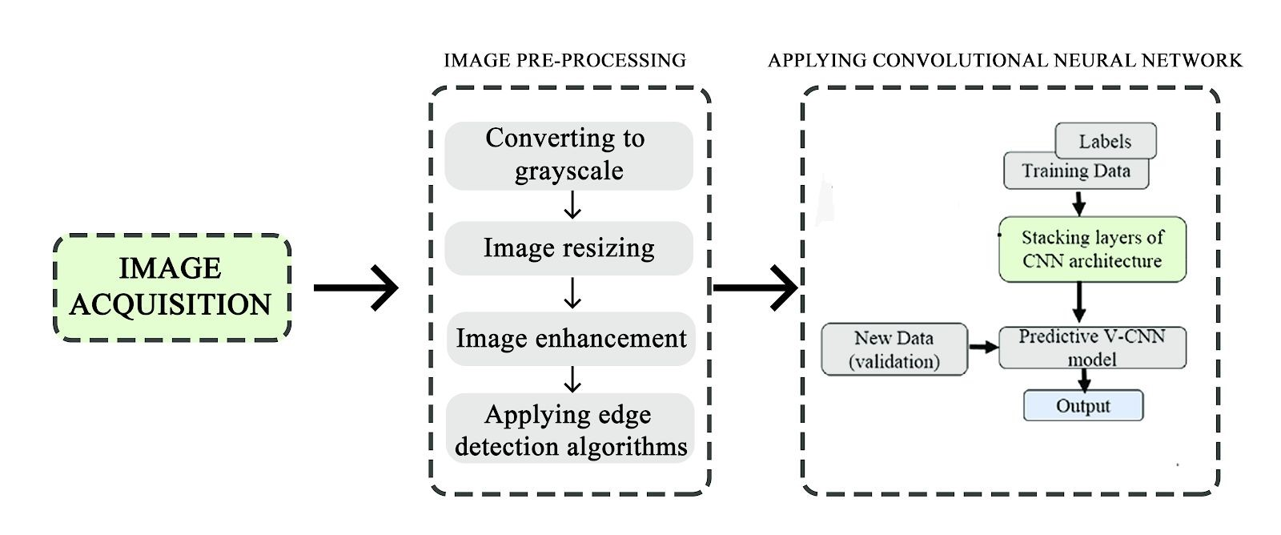

***( Block diagram representing the working )***

# 9. EXPERIMENTAL ANALYSIS

## **9.1 Image Pre-processing**

### **9.1.1 Results observed using Adaptive Threshold Vs Binary Threshold**

### **9.1.1.1 Binary Threshold**

Itis​ a technique, which is the assignment of pixel values in relation to the threshold value provided. In thresholding, each pixel value is compared with the threshold value. If the pixel value is smaller than the threshold, it is set to 0, otherwise, it is set to a maximum value (generally 255). Thresholding is a very popular segmentation technique, used for separating an object considered as a foreground from its background. A threshold is a value that has two regions on its either side i.e. below the threshold or above the threshold.

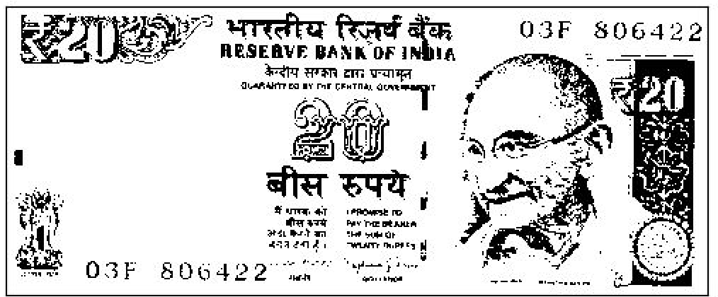

**9.11.2 Adaptive Threshold**

In Simple Thresholding, the global value of threshold was used which remained constant throughout. So, a constant threshold value won’t help in the case of variable lighting conditions in different areas. Adaptive thresholding is the method where the threshold value is calculated for smaller regions. This leads to different threshold values for different regions with respect to the change in lighting.

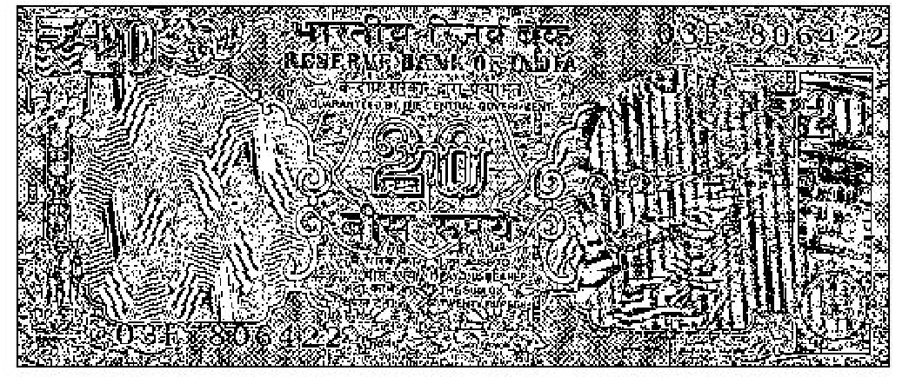

### **9.1.2 Contours Representing Regions of Interest**

Contours can be explained simply as a curve joining all the continuous points (along the boundary), having the same color or intensity. The contours are a useful tool for shape analysis and object detection and recognition.

Here the diagram that describe the contours representing regions of intrest

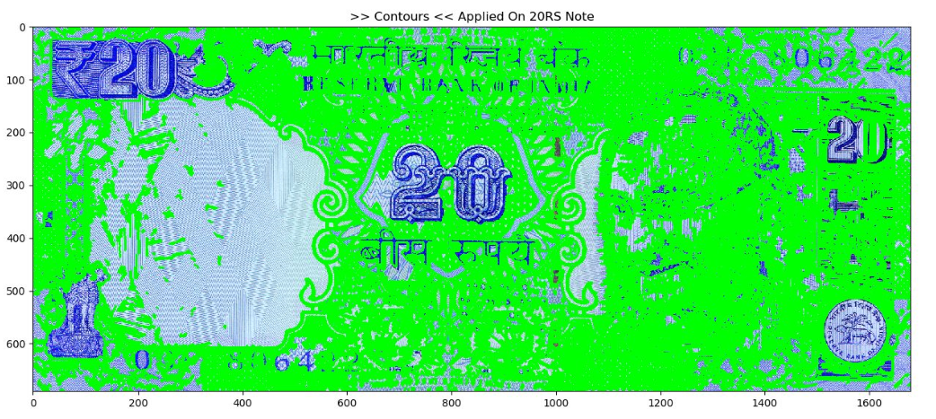

### **9.1.3 Canny Edge Detection**

Canny edge detection is a technique to extract useful structural information from different vision objects and dramatically reduce the amount of data to be processed. It has been widely applied in various computer vision systems. Canny has found that the requirements for the application of edge detection on diverse vision systems are relatively similar. Thus, an edge detection solution to address these requirements can be implemented in a wide range of situations.

The Process of the Canny edge detection algorithm:

1. Apply Gaussian filter to smooth the image in order to remove the noise
2. Find the intensity gradients of the image
3. Apply non-maximum suppression to get rid of spurious response to edge detection
4. Apply double threshold to determine potential edges
5. Track edge by hysteresis: Finalize the detection of edges by suppressing all the other edges that are weak and not connected to strong edges.

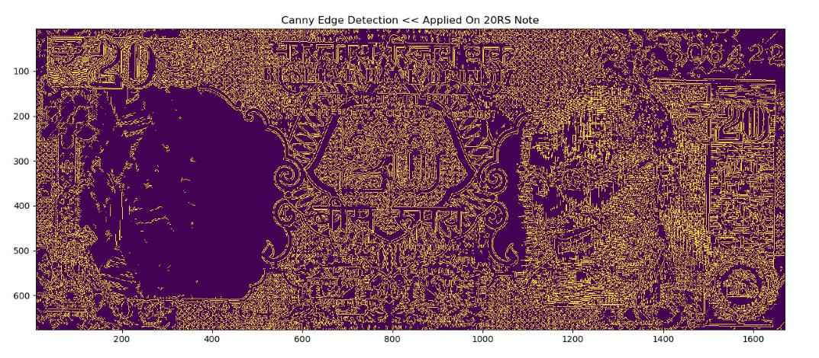

## **9.2 Training and Testing Neural Network Model**

### **9.2.1 Supervised machine learning**

It is based on the idea that a user can select sample pixels in an image that are representative of specific classes and then direct the image processing software to use these training sites as references for the classification of all other pixels in the image. Training sites (also known as testing sets or input classes) are selected based on the knowledge of the user.

### . **9.2.2 Convolutional Neural Network**

Convolutional Neural Network has an input layer, an output layer, and hidden layers. The hidden layers usually consist of convolutional layers, ReLU layers, pooling layers, and fully connected layers.

Convolutional layers apply a convolution operation to the input. This passes the information on to the next layer.

Pooling combines the outputs of clusters of neurons into a single neuron in the

next layer.

Fully connected layers connect every neuron in one layer to every neuron in the next layer.

CNN works by extracting features from images. This eliminates the need for manual feature extraction. The features are not trained! They’re learned while the network trains on a set of images. This makes deep learning models extremely accurate for computer vision tasks. CNN’s learn feature detection through tens or hundreds of hidden layers. Each layer increases the complexity of the learned features.

#### **9.3 Activation Function**

It is used to determine the output of neural network like yes or no. It maps the resulting values in between 0 to 1 or -1 to 1 etc. (depending upon the function).

##### **9.3.1. ReLU (Rectified Linear Unit) Activation Function**

The ReLU is the most used activation function in the world right now. Since it is used in almost all the convolutional neural networks or deep learning.

As you can see, the ReLU is half rectified (from bottom). f(z) is zero when z is less than zero and f(z) is equal to z when z is above or equal to zero.

Range: [ 0 to infinity)

The function and its derivative both are monotonic.

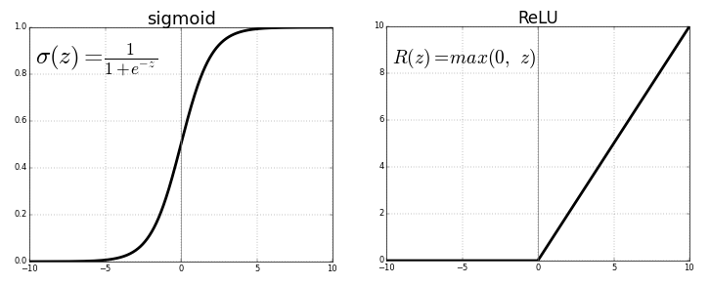

#### **9.3.2 Pooling**

Pooling progressively reduces the size of the input representation. It makes it possible to detect objects in an image no matter where they’re located. Pooling helps to reduce the number of required parameters and the amount of computation required. It also helps control overfitting.

#### **9.3.3 Flattening**

You flatten the pooled feature map into a sequential column of numbers (a long vector). This allows that information to become the input layer of an artificial neural network for further processing.

#### **9.3.4 Dropout**

A dropout is an approach to regularization in neural networks which helps to reduce interdependent learning amongst the neurons. It prevents overfitting of data.

#### **9.3.4 Effect of batch size**

Higher batch sizes lead to lower asymptotic test accuracy. Using​ too large a batch size can have a negative effect on the accuracy of your network during training since it reduces the stochasticity of the gradient descent.

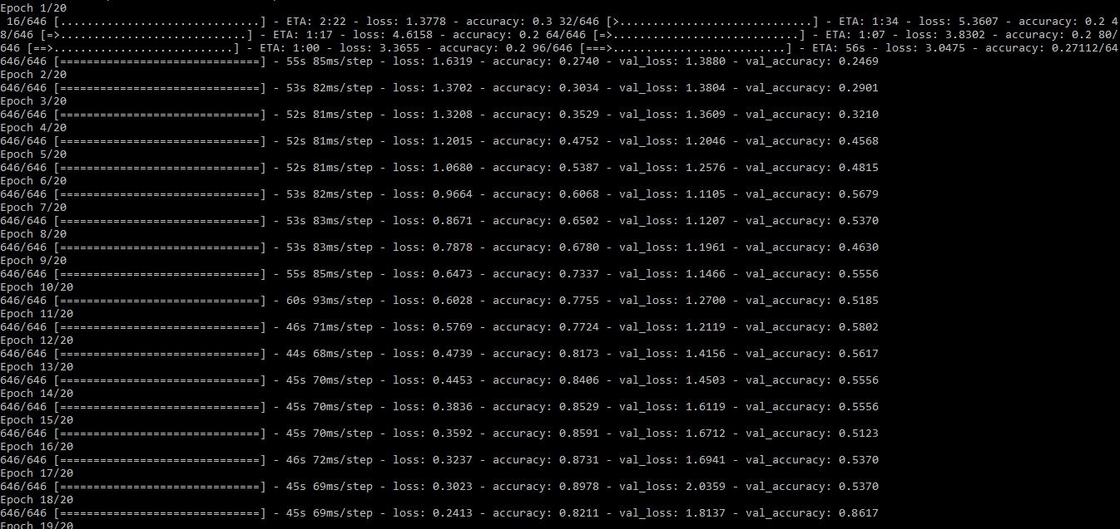

## (Batch size : 400 Validation accuracy: ~80%​ )

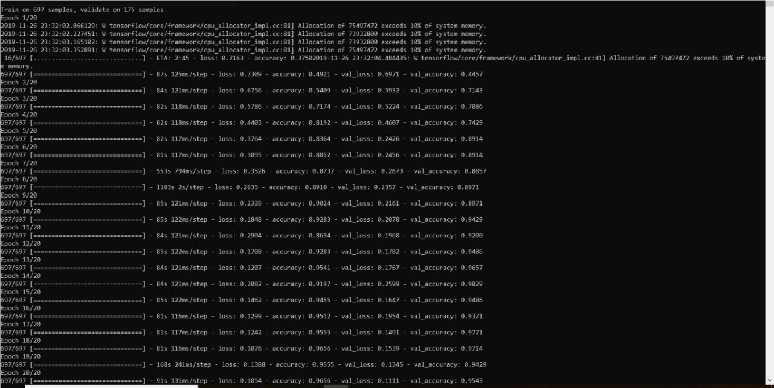

## (Batch size : 100 Validation accuracy: ~95%​ )

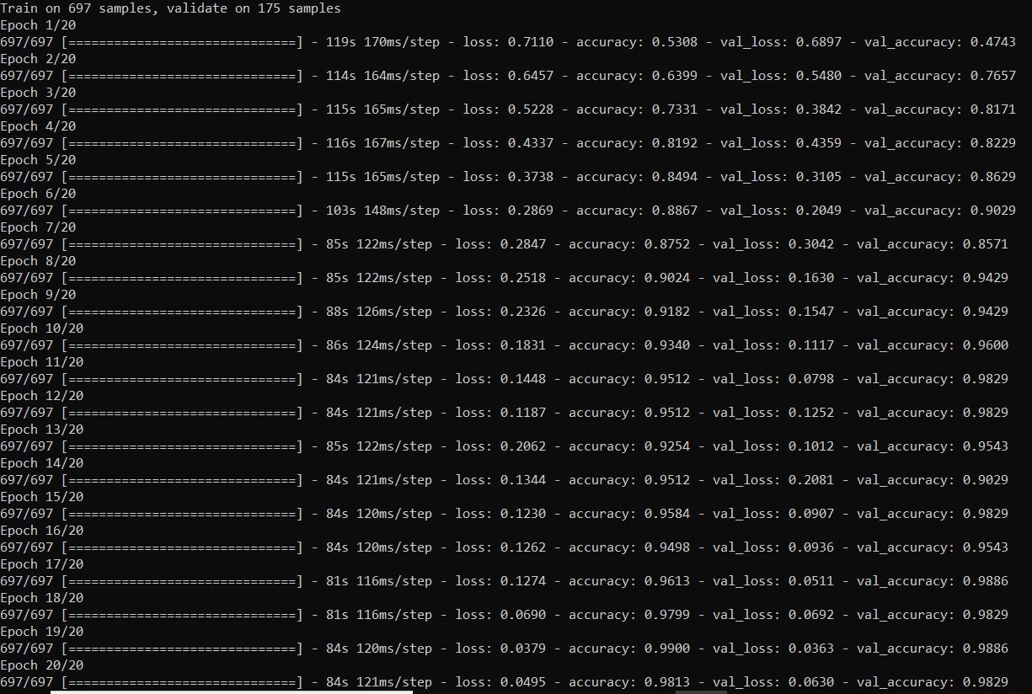

## (Batch size : 16 Validation accuracy: ~98%​ )

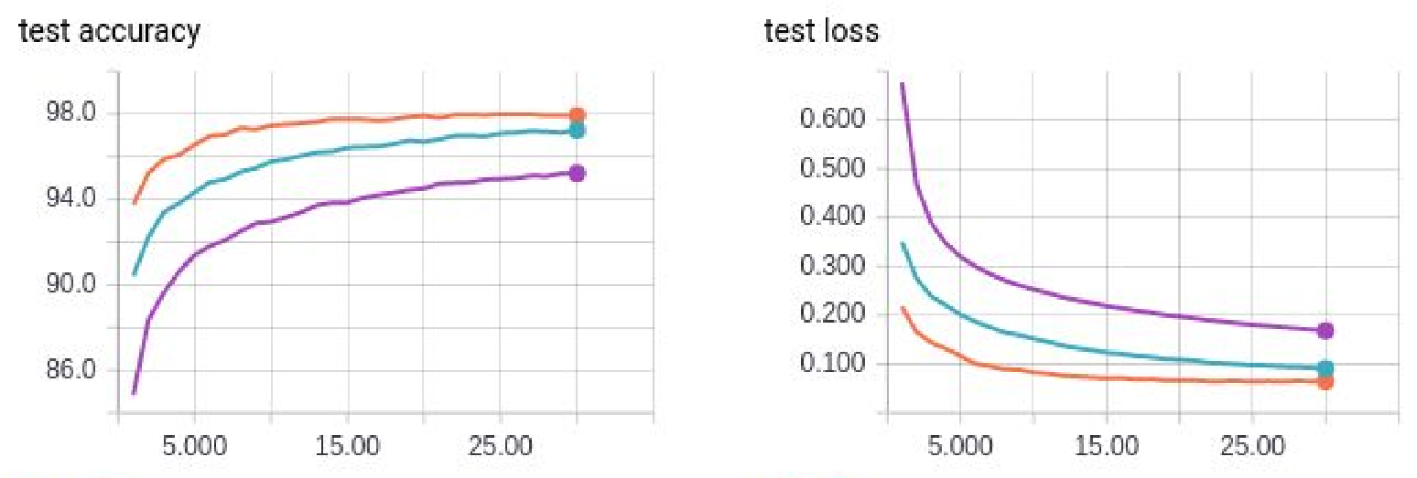

***Orange curves: batch size 16***

***Blue curves: batch size 100***

***Purple curves: batch size 400***

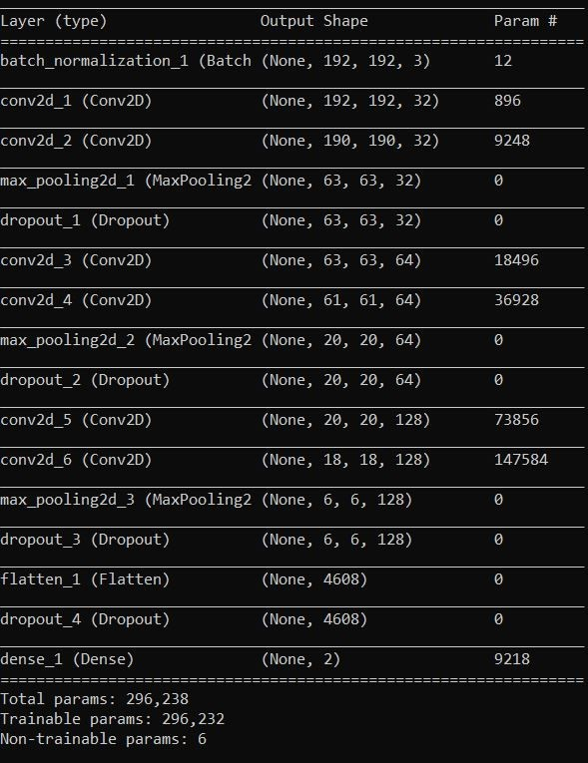 ***(***​ ***Visualizing the Model)***

# Results

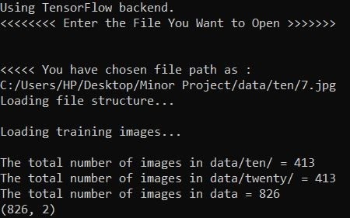

## (​ Importing Test Image and Training Data)

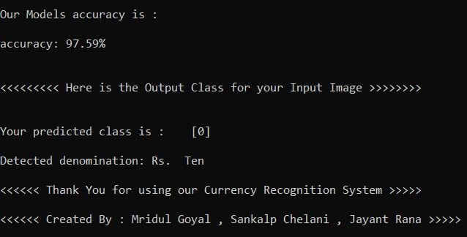

***(Final Result validated on ten rupee note)***

# Tools and Environment

1. Python IDE
2. Sublime Text Editors

# Python Libraries used

1. Keras
2. TensorFlow
3. Numpy
4. Cv2
5. Matplotlib

**10. System Design**

**10.1 Architecture Diagram**

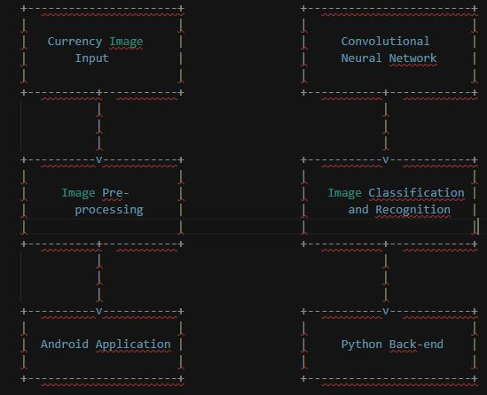

**10.2 Use-case Diagram**

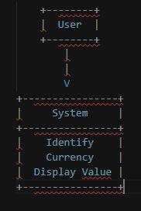

**10.3 Data Flow Diagram**

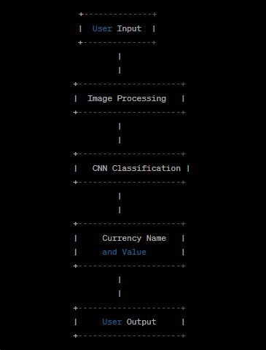

**10.4 Modular Design**

Modular design is a method of designing a system or application by breaking it down into smaller, more manageable parts or modules. Each module is designed to perform a specific function or task and can be tested and debugged independently of the other modules. This approach makes the system more flexible, maintainable, and scalable.

For the Indian Currency Identifier project, a modular design approach can be used to break down the system into the following modules:

**Image processing module**: This module is responsible for preprocessing the input currency image by applying edge detection, image thresholding, and contour detection techniques. It is implemented in Python using OpenCV library.

**Convolutional neural network (CNN) module**: This module is responsible for the actual currency recognition task. It takes the preprocessed image as input and outputs the name and value of the recognized currency. The CNN is trained using a large dataset of currency images and is implemented in Python using TensorFlow library.

**User interface (UI) module:** This module is responsible for providing a user-friendly interface for the users to interact with the system. It allows users to upload an image of the currency they want to identify and displays the results. The UI is implemented using HTML, CSS, and JavaScript.

**Dataset module:** This module is responsible for storing the currency images and their corresponding labels for training the CNN.

**Deployment module:** This module is responsible for deploying the system on a mobile platform. It involves packaging all the modules into a single executable file or package and deploying it on a mobile device.By breaking down the system into these modular components, each module can be developed, tested, and maintained independently, making the system more efficient and scalable.

**11. SYSTEM ANALYSIS**

System analysis is the process of examining and defining the components and structure of a system in order to identify its strengths and weaknesses and determine potential areas for improvement. In the context of the "Indian Currency Identifier" project, system analysis involves examining the various aspects of the system, such as its requirements, design, functionality, and performance, to ensure that it meets the needs of its users and stakeholders.

**11.1 Existing System**

The existing system for currency identification involves manual recognition by individuals who possess knowledge of the different currencies around the world. They visually examine the banknotes to identify the country and denomination of the currency. This process can be time-consuming and prone to errors, particularly when dealing with currencies from countries that are unfamiliar to the individual.

Blind individuals, who cannot visually examine banknotes, face an even greater challenge in identifying currencies. They often rely on assistance from sighted individuals or specialized devices that convert currency values to audio or braille output. However, these devices can be expensive and not easily accessible.

In summary, the existing system for currency identification relies heavily on human expertise and can be cumbersome for blind individuals. The proposed mobile application aims to overcome these limitations by utilizing computer vision and machine learning algorithms to provide fast and accurate currency identification.

**11.1.1 Drawbacks**

**Lack of Standardization:** There is no standardization in the tactile markings used on Indian currency notes, which makes it difficult for visually impaired individuals to identify notes when traveling across different regions.

**Inaccuracies in identification:** Even with the use of various identification methods, there can still be inaccuracies in identifying Indian currency.

**11.2 Proposed System**

The proposed system is a mobile application called "Indian Currency Identifier" that utilizes convolutional neural network (CNN) and image processing techniques to identify different currencies from around the world. The main aim of the proposed system is to provide a fast and reliable way to identify Indian currencies, including notes of 10, 20, 50, 100, 200, 500, and 2000 denominations.

The proposed system aims to overcome the limitations of the existing system by providing a more accurate and reliable way to identify currencies. It utilizes a convolutional neural network trained on a large dataset of currency images to identify various features and patterns that differentiate one currency from another.

The user interface of the currency identifier is simple and intuitive, allowing users to easily upload an image of the currency they want to identify. The system processes the image and provides the user with the name and value of the currency. The currency identifier can be useful for individuals who frequently travel internationally or for businesses that deal with foreign currencies on a regular basis.

One of the key advantages of the proposed system is that it is designed to be more accessible for visually impaired individuals. The system can provide an audio description of the currency, making it easier for visually impaired individuals to use the application. Additionally, the proposed system can be extended to include more currencies from around the world, making it more versatile and useful for a wider range of users.

Overall, the proposed system is designed to provide a more accurate, reliable, and accessible way to identify currencies, overcoming the limitations of the existing system.

**11.2.1 Merits**

The proposed system offers several advantages over the existing system. It is faster, more accurate, and can recognize a wider range of currencies. Additionally, it has a simple and intuitive user interface, making it easy to use for individuals who are visually impaired. The system also has the potential for future enhancements, such as the ability to recognize additional currencies from different countries. Overall, the proposed system provides a more efficient and effective way to identify currencies

**12. IMPLEMENTATION**

**12.1 Front end**

**Loading.html**

<!DOCTYPE html>

<html>

<head>

<meta charset="UTF-8">

<title>Currency Identifier</title>

<link rel="stylesheet" href="Css/index.css">

<link rel="preconnect" href="https://fonts.googleapis.com">

<link rel="preconnect" href="https://fonts.gstatic.com" crossorigin>

<link href="https://fonts.googleapis.com/css2?family=Architects+Daughter&display=swap" rel="stylesheet">

</head>

<body>

<div class="heading">

<h2> <b>CURRENCY IDENTIFIER</b> </h2>

</div>

<div class="image">

<img src="Resources/logo1.png" alt="logo">

</div>

<div class="loader">

<div class="dot"></div>

<div class="dot"></div>

<div class="dot"></div>

</div>

<div class="loading">

<h1>Loading</h1>

</div>

</div>

</body>

</html>

**Loading.css**

body{

background: linear-gradient(to right,#1F2058 1%,#00083E);

}

.image{

text-align: center;

}

img {

transform: rotate(-20deg);

max-width: 100%;

width: 700px;

height: auto;

margin-top: 50%;

margin-bottom: 60%;

}

.heading{

font-family: 'Architects Daughter', 'Times New Roman', Times, serif;

display: flex;

justify-content: center;

text-align: center;

color:#52FBDD;

font-size: 40px;

margin-top:50px;

}

.loader {

display: flex;

justify-content: center;

align-items: center;

height: 100%;

}

.dot {

height:20px;

width: 20px;

border-radius: 50%;

background-color:yellow;

margin: 10px;

animation: pulse 1.5s ease-in-out infinite;

}

.dot:nth-child(2) {

animation-delay: 0.5s;

}

.dot:nth-child(3) {

animation-delay: 1s;

}

@keyframes pulse {

0% {

transform: scale(0.8);

}

50% {

transform: scale(1.2);

}

100% {

transform: scale(0.8);

}

}

h1 {

font-family: 'Architects Daughter', cursive;

position: relative;

text-align: center;

font-size: 2.5em;

color: #52FBDD;

text-transform: uppercase;

}

h2{

letter-spacing: 8px;

font-stretch: extra-condensed;

}

**Main.html**

<!DOCTYPE html>

<html lang="en">

<head>

<meta charset="UTF-8">

<meta http-equiv="X-UA-Compatible" content="IE=edge">

<meta name="viewport" content="width=device-width, initial-scale=1.0">

<title>Document</title>

<link rel="stylesheet" href="Css/second.css">

<link rel="preconnect" href="https://fonts.googleapis.com">

<link rel="preconnect" href="https://fonts.gstatic.com" crossorigin>

<link href="https://fonts.googleapis.com/css2?family=Sansita&display=swap" rel="stylesheet">

</head>

<body>

<div class="info">

<p><b>Indian Currency Identifier</b></p>

</div>

<div class="container">

<center>

<form enctype="multipart/form-data" method="POST" action="your-server-side-script.php">

<label for="fileInput">

<img src="Resources/camera.png" alt="camera">

</label>

<input type="file" accept="image/*" id="fileInput" capture="camera" onchange="this.form.submit();">

<button type="button" id="captureButton" class="camera">

<img src="Resources/gallery.png" alt="gallery">

</button>

</form>

</center>

</div>

<script>

const fileInput = document.getElementById("fileInput");

const captureButton = document.getElementById("captureButton");

// Open camera when capture button is clicked

captureButton.addEventListener("click", () => {

fileInput.removeAttribute("capture");

fileInput.click();

fileInput.setAttribute("capture", "camera");

});

</script>

<div class="or">

<p>or</p>

</div>

<div class="add">

<p><b>Add your currency</b></p>

</div>

<div class="note">

<p>Note : This application is used to only identify the indian currency and mainly coins are not allowed to predict...!

</p>

</div>

</body>

</html>

**Main.css**

body{

background: linear-gradient(to right,#1F2058 1%,#00083E);

}

.info{

font-family: 'Sansita', sans-serif;

text-transform: uppercase;

color: #52FBDD;

text-align: center;

font-size: 18px;

}

.info p{

margin-top: 9%;

margin-bottom: 50%;

word-spacing: 10px;

}

.container {

width: auto;

margin-right: 30px;

}

img {

width: 100px;

height: 100px;

margin: 20px;

margin-bottom:0;

}

input[type="file"] {

color: transparent;

margin: auto;

}

button{

border: none;

background-color: transparent;

width: 110px;

height: 110px;

margin-left: 50px;

margin-bottom:auto;

}

input[type="file"] {

position: absolute;

opacity: 0;

top: 0;

left: 0;

bottom: 0;

right: 0;

}

label {

display: inline-block;

width: 100px;

height:100px;

margin: auto;

}

.or{

color: #52FBDD;

font-family: 'Sansita', sans-serif;

margin-bottom: 100px;

text-transform: uppercase;

text-align: center;

}

.note{

color: #52FBDD;

text-align: center;

font-family: 'Sansita', sans-serif;

margin-top: 170px;

}

.add{

position: relative;

color: #52FBDD;

text-align: center;

font-family: 'Sansita', sans-serif;

text-transform: uppercase;

font-size: 20px;

margin-bottom:auto;

bottom: 50px;}

**12.2 Backend**

**Training_model.py**

import numpy as np

import pandas as pd

from sklearn.model_selection import train_test_split

from sklearn.preprocessing import LabelEncoder

from sklearn.preprocessing import OneHotEncoder

from sklearn.utils import shuffle

import cv2 as cv

import keras

from keras.preprocessing import image

from keras.layers import Conv2D,Flatten, Dense, MaxPool2D,MaxPooling2D, Activation,

Dropout, BatchNormalization, Input

# from keras.layers.convolutional import Convolution2D

from keras.models import Sequential, Model

from keras.utils import np_utils, to_categorical

from keras.callbacks import EarlyStopping, ModelCheckpoint

import os

import glob

import warnings

warnings.filterwarnings("ignore", category=DeprecationWarning)

PATH = os.getcwd()

print('path'+PATH)

total_images = 0

data_path = PATH + '/data'

print('data path'+data_path)

major = os.listdir(data_path)

print('major')

print(major)

full_path = []

image_labels = []

all_labels = ['10','20','50','100','200','500','2000','Background']

print("Loading file structure...\n")

for a in major:

full_path.append("data/"+a+'/')

print(full_path)

print("Loading training images...\n")

train_images = []

for i in full_path:

images_in_folder = 0

label = i.split('/')[1]

for file in glob.glob(i+"*.jpg"):

img = cv.cvtColor(cv.imread(file),cv.COLOR_BGR2RGB)

img = cv.resize(img, (192,192))

total_images+=1

train_images.append(img)

image_labels.append(all_labels.index(label))

images_in_folder += 1

print("The total number of images in %s = %d" % (i,images_in_folder))

print("The total number of images in data = " + str(total_images))

X_train = np.array(train_images, np.float32) / 255.

image_labels = to_categorical(image_labels)

mean_img = X_train.mean(axis=0)

std_dev = X_train.std(axis = 0)

X_norm = (X_train - mean_img)/ std_dev

X_norm, image_labels = shuffle(X_norm, image_labels, random_state=0)

# Creating train validation split

Xtrain, Xvalid, Ytrain, Yvalid = train_test_split(X_norm, image_labels, test_size=0.2, random_state=7)

#Training the Model

print("<<<<<< Now we will Train our model >>>>> \n")

model = Sequential()

model.add(BatchNormalization(input_shape=Xtrain.shape[1:]))

model.add(Conv2D(32, kernel_size=(3, 3), activation= 'relu',padding= 'same'))

model.add(Conv2D(32, kernel_size=(3, 3), activation= 'relu'))

model.add(MaxPooling2D(pool_size=(3,3)))

model.add(Dropout(0.4))

model.add(Conv2D(64, kernel_size=(3, 3), activation= 'relu', padding='same'))

model.add(Conv2D(64, kernel_size=(3, 3), activation= 'relu')

model.add(MaxPooling2D(pool_size=(3,3)))

model.add(Dropout(0.3))

model.add(Conv2D(128, kernel_size=(3, 3), activation= 'relu', padding='same'))

model.add(Conv2D(128, kernel_size=(3, 3), activation= 'relu'))

model.add(MaxPooling2D(pool_size=(3,3)))

model.add(Dropout(0.3))

model.add(Flatten())

model.add(Dropout(0.5))

model.add(Dense(8, activation='softmax'))

model.compile(loss='categorical_crossentropy', optimizer='adam', metrics=['accuracy'])

model.summary()

model.get_config()

model.layers[0].get_config()

model.layers[0].input_shape

model.layers[0].output_shape

model.layers[0].get_weights()

np.shape(model.layers[0].get_weights()[0])

model.layers[0].trainable

early_stops = EarlyStopping(patience=3, monitor='val_acc')

trained_model = model.fit(Xtrain, Ytrain, epochs = 10, shuffle = True, batch_size =

8,validation_data=(Xvalid,Yvalid))

model.save('model_final_B7.h5')

print("<<<< Thanks for Training Your Model Has been trained >>>>>")

# # visualizing losses and accuracy

# train_loss=trained_model.history['loss']

# val_loss=trained_model.history['val_loss']

# train_acc=trained_model.history['acc']

# val_acc=trained_model.history['val_acc']

# xc=range(20)

# plt.figure(1,figsize=(7,5))

# plt.plot(xc,train_loss)

# plt.plot(xc,val_loss)

# plt.xlabel('num of Epochs')

# plt.ylabel('loss')

# plt.title('train_loss vs val_loss')

# plt.grid(True)

# plt.legend(['train','val'])

# #print plt.style.available # use bmh, classic,ggplot for big pictures

# plt.style.use(['classic'])

# plt.figure(2,figsize=(7,5))

# plt.plot(xc,train_acc)

# plt.plot(xc,val_acc)

# plt.xlabel('num of Epochs')

# plt.ylabel('accuracy')

# plt.title('train_acc vs val_acc')

# plt.grid(True)

# plt.legend(['train','val'],loc=4)

# #print plt.style.available # use bmh, classic,ggplot for big pictures

# plt.style.use(['classic'])

**Predict.py**

import os

import glob

from utils import *

from matplotlib import pyplot as plt

import numpy as np

# For Audio

import subprocess

import playsound

import pygame

from gtts import gTTS

# To Open Dialogue box

import tkinter as tk

from tkinter import filedialog

# Importing keras

from keras import backend as K

# Importing Open CV

import cv2 as cv

# Scikit PreProcessing

from sklearn.model_selection import train_test_split

from sklearn.preprocessing import LabelEncoder

from sklearn.preprocessing import OneHotEncoder

from sklearn.utils import shuffle

# Importing warnings

import warnings

warnings.filterwarnings("ignore", category=DeprecationWarning)

# Import Keras Python

import keras

from keras.preprocessing import image

from keras.layers import Conv2D, Flatten, Dense, MaxPool2D, MaxPooling2D, Activation, Dropout, BatchNormalization, Input

from keras.models import Sequential, Model, load_model

from keras.utils import np_utils, to_categorical

from keras.callbacks import EarlyStopping, ModelCheckpoint

# Importing time

import time

print("<<<<<<<< Enter the File You Want to Open >>>>>>>")

print("\n")

#time.sleep(5)

root = tk.Tk()

root.withdraw()

file_path = 'data\\50\\201.png'

print("<<<<< You have chosen file path as : ")

print(file_path)

#time.sleep(5)

PATH = os.getcwd()

total_images = 0

data_path = PATH + '/data'

major = os.listdir(data_path)

full_path = []

image_labels = []

all_labels = ['10', '20', '50', '100', '200', '500', '2000']

print("Loading file structure...\n")

for a in major:

full_path.append("data/" + a + '/')

print("Loading training images...\n")

train_images = []

for i in full_path:

images_in_folder = 0

label = i.split('/')[1]

for file in glob.glob(i + "*.png"):

img = cv.cvtColor(cv.imread(file), cv.COLOR_BGR2RGB)

img = cv.resize(img, (192, 192))

total_images += 1

train_images.append(img)

image_labels.append(all_labels.index(label))

images_in_folder += 1

print("The total number of images in %s = %d" % (i, images_in_folder))

print("The total number of images in data = " + str(total_images))

# Label shape

X_train = np.array(train_images, np.float32) / 255.

image_labels = to_categorical(image_labels)

print(image_labels.shape)

mean_img = X_train.mean(axis=0)

std_dev = X_train.std(axis=0)

X_norm = (X_train - mean_img) / std_dev

X_norm, image_labels = shuffle(X_norm, image_labels, random_state=0)

# Creating train validation split

Xtrain, Xvalid, Ytrain, Yvalid = train_test_split(X_norm, image_labels, test_size=0.2, random_state=7)

# # load model

model = load_model('model_final_B8.h5')

# summarize model.

print("<<<<<< This is the Model We Trained >>>>>>>> \n")

#time.sleep(5)

#model.summary()

score = model.evaluate(Xvalid, Yvalid, verbose=0)

print("\n")

print("Our Models accuracy is : \n ")

print("%s: %.2f%%" % (model.metrics_names[1], score[1] * 100))

print("\n")

# load the model we saved

model.compile(loss='categorical_crossentropy',

optimizer='adam',

metrics=['accuracy'])

# predicting images

print("<<<<<<<<< Here is the Output Class for your Input Image >>>>>>>>")

print("\n")

img = cv.cvtColor(cv.imread(file_path),cv.COLOR_BGR2RGB)

img = cv.resize(img, (192,192))

img = np.reshape(img,[1,192,192,3])

img= np.array(img, np.float32) / 255.

classes = model.predict(img, batch_size=1)

print ("Your predicted class is : ",classes)

# Findig max value in the classes

ind=classes.argmax()

# This is for soud

pygame.mixer.init()

# Checking the index through classes and play the predicted sound

if(ind==0):

a='10'

print('The currency is '+a)

# playsound.playsound('audio/10.mp3', True)

pygame.mixer.music.load('audio/10.mp3')

pygame.mixer.music.play()

# Wait for 10 seconds

pygame.time.delay(1000)

elif(ind==1):

a='20'

print('The currency is ' + a)

pygame.mixer.music.load('audio/20.mp3')

pygame.mixer.music.play()

# Wait for 10 seconds

pygame.time.delay(1000)

elif(ind==2):

a='50'

print('The currency is ' + a)

pygame.mixer.music.load('audio/50.mp3')

pygame.mixer.music.play()

# Wait for 10 seconds

pygame.time.delay(1000)

elif(ind==3):

a='100'

print('The currency is ' + a)

pygame.mixer.music.load('audio/100.mp3')

pygame.mixer.music.play()

# Wait for 10 seconds

pygame.time.delay(1000)

elif(ind==4):

a='200'

print('The currency is ' + a)

pygame.mixer.music.load('audio/200.mp3')

pygame.mixer.music.play()

# Wait for 10 seconds

pygame.time.delay(1000)

elif(ind==5):

a='500'

print('The currency is ' + a)

pygame.mixer.music.load('audio/500.mp3')

pygame.mixer.music.play()

# Wait for 10 seconds

pygame.time.delay(1000)

else:

a='2000'

print('The currency is ' + a)

pygame.mixer.music.load('audio/2000.mp3')

pygame.mixer.music.play()

# Wait for 10 seconds

pygame.time.delay(1000)

# Stop playback

pygame.mixer.music.stop()

pygame.mixer.quit()

print('\nDetected denomination: Rs. ', a,"\n")

#time.sleep(5)

print("<<<<<< Thank You for using our Currency Recognition System >>>>> \n\

**13. SYSTEM TESTING**

**13.1 Testing Types**

**Unit Testing**:

This type of testing focuses on individual units or components of the application. In the case of the currency identifier application, this would involve testing individual functions and methods of the application to ensure that they work as intended.

**Integration Testing:**

Integration testing involves testing how different components of the application work together. For the currency identifier application, this would involve testing how the front-end and back-end components of the application work together, as well as how the image processing and CNN components of the application work together.

**System Testing:**

This type of testing involves testing the application as a whole to ensure that it meets its functional and non-functional requirements. For the currency identifier application, this would involve testing the entire application to ensure that it can correctly identify different currencies and provide accurate information about their value.

**Acceptance Testing:**

Acceptance testing involves testing the application against the requirements and expectations of the end-users or stakeholders. For the currency identifier application, this would involve testing the application with a group of end-users to ensure that it meets their needs and is easy to use.

**Regression Testing**:

Regression testing involves testing the application after changes or updates have been made to ensure that existing functionality has not been affected. For the currency identifier application, this would involve testing the application after any updates or improvements have been made to ensure that it still works correctly.

**13.2 Testing Techniques**

**White Box Testing**

White-box testing and black-box testing are two different testing techniques. White-box testing involves testing the internal workings of the system, while black-box testing involves testing the system from the perspective of an external user, without knowledge of the internal workings.

White-box testing can be used to test the various components of the application, such as the convolutional neural network, image processing algorithms, and user interface. This can involve testing individual functions and methods within the code, as well as testing the interactions between different components.

**Black Box Testing**

Black-box testing can be used to test the application as a whole, from the perspective of a user. This can involve testing various use cases, such as uploading an image of a currency note, processing the image, and identifying the currency. Black-box testing can also involve testing for usability, user experience, and accessibility, such as testing how the application performs for users with visual impairments or different levels of technical proficiency.

**14. Conclusion**

Paper Currency Recognition is an important application of Pattern Recognition. Many studies have been conducted to recognize paper currencies using Image Processing techniques. While these methods have shown to be accurate, there is still room for improvement in terms of processing time. The proposed algorithm is fully automatic and requires no human intervention, making it an efficient and reliable solution.

The dataset used for this project is a standard Kaggle dataset that contained approximately 2123 images. Initially, the dataset was skewed, and required filtering to create a uniform dataset of 1732 images for training. The images in the dataset included various types of banknotes such as blurred notes, folded notes, worn and torn notes, etc. In our project, we have also attempted to solve the issue of illumination in the images, which is a common challenge in image processing. Additionally, some images in the dataset had irregular orientations.

To classify the images, we have used a Convolutional Neural Network (CNN), which is a highly efficient neural network that is commonly used for image classification. CNN image classifications take an image as input, apply preprocessing, and classify it under defined categories. The dataset was classified into four classes, with each class labeled as Ten, Twenty, Fifty, and Hundred rupees banknote.

ATMs, vending machines, and currency exchange services. As the project is still a work in progress, future updates will aim to address the issue of noisy images and improve processing time.

**15. Future Enhancement**

Adding various countries to the currency recognition application can be a significant enhancement to the system. This would allow users to easily identify and recognize banknotes from different countries without the need for separate applications or manual recognition.To implement this enhancement, the system would need to be trained on datasets containing images of banknotes from different countries. These datasets can be obtained from various sources, such as open datasets or through collaborations with banks and financial institutions.

**16. Reference**

1. *Indian Paper Currency Authentication System using Image processing, Journal of Scientific Research Engineering & Technology (IJSRET), ISSN 2278 – 0882 Volume 4, Issue 9, September 2015.*
2. *Indian Currency Recognition using Neural Network Pattern Recognition Tool Volume 2, 2017, Pages 67–72 ICRISET2017. International Conference on Research and Innovations in Science, Engineering & Technology.*
3. *A Survey on Fake Indian Paper Currency Identification System*

*Volume 6, Issue 7, July 2016 ISSN: 2277 128X International Journal of Advanced Research in Computer Science and Software Engineering*

1. *Currency recognition using a smartphone: Comparison between color SIFT and grayscale SIFT algorithms.*

*Journal of King Saud University – Computer and Information Sciences* [​*Volume 29, Issue 4*​*,*](https://www.sciencedirect.com/science/journal/13191578/29/4) *Pages 484-492, October 2017*

1. *Feature extraction for paper currency recognition.*

*2007 9th International Symposium on Signal Processing and Its Applications.*

1. *An intelligent paper currency recognition system*

*International Conference on Communication, Management and Information Technology (ICCMIT 2015)*

1. *Deep Convolutional Neural Networks for Hyperspectral Image Classification Journal of Sensors, Volume 2015, Article ID 258619, 12 pages*

**17. Appendix**

**17.1 Screenshots**

